Palisades Charter High School
Band, Drum Line and Color Guard

2019-20 Handbook

Alex Dale, Director
Palisades Charter High School
15777 Bowdoin Street
Pacific Palisades, California 90272

palihighbands@gmail.com (band operations)

Letter from the Director…………………………………………………………………………………………..……………3
Mission Statement and Values……………………………………………………………………………………………….4
Standards of Behavior vs. Discipline………………………………………………………………………………………...5

Code of Conduct
Grading System

Competition

Attendance

School Spirit

Pali Band Student Leaders…………………………………………….…………………………………………………….7

The Staff……………………...……………………………………………………………………………………………….11

Curriculum and Course Offerings…………………………………………………………………………………………..12

Wind Ensemble Audition Information & Information Sheet……………………………………………………………...15

Parent Welcome and Information…………………………………………………………………………………………..17

Top Ten Things You Should Know as a Band Parent

Fair-Share Donation & Tax-Deductible Direct Donation Policy…………………………………..……………..………19

Charms…..……………………………………………………………………………………………………………………21

Equipment/Uniform…………………………………………………………………………………………………………..22

Rehearsal Dress

Marching Band Uniform and Care..………………………………………………………………………………23

Concert Attire Guidelines…………………………………………………………………………………………..26

Student Supplies……………………………………………………………………………………......................27

Master Schedule……………………………………………………………………………………………………………..30

Form Check list………………………………………………………………………………….……………………………32

Parent Signature Form………………………………………………………………………………………………………33

Marching Band, Drum Line & Color Guard Parent Volunteer Form…………………………………………………....34

Pali Band Gear Order Form………………………………………………………………………………………………...35

2017-18 Financial Assistance Application………………………………………………………………………………...36

Dear Pali Band Families,

Please keep this handbook around and use this as a guide to the season. Hopefully, most questions that you may have will be answered through the information given here. This program has a reputation, rightly deserved, as one of the best in the area and that is entirely because of the excellence and accountability of our students and staff. I hope you have a great experience in the Palisades Charter High School band program!

Best,
Alex Dale

Mission Statement

Through the medium of performance, the Palisades Charter High School Bands, Drum Line and Color Guard will inspire in members a life-long love of music, and teach enduring lessons our alumni will carry with them well after they graduate.

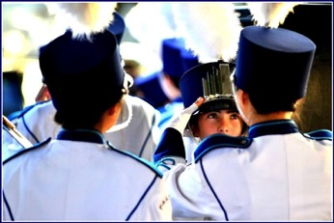

Values

1. Family:
Pali Band welcomes every student who is willing to devote his or her time and energy to the organization, regardless of individual circumstances. In return for their dedication, the band offers a home and sense of family to all of its members, and strives to develop an environment characterized by caring and acceptance.
2. Respect:
All members of Pali Band actively demonstrate respect for themselves, their instructors, and their peers, while striving to earn the appreciation of the school and community at large. Pali Band members are respectful of their equipment, uniforms, and facilities with the knowledge that their actions reflect the organization as a whole.
3. Discipline:
As members of Pali Band, students will develop a greater understanding of the discipline and focus performance demands. While doing so, they will learn that they are responsible both to themselves, and to the ensemble.
4. Performance:
Members of Pali Band regularly practice outside of rehearsal to ensure that rehearsal time can be devoted solely to learning how individual members contribute to the collective, designed goal of each season. Over the course of their high school careers, Pali Band members will develop performance skills as the band strives to achieve expressive excellence.
5. Leadership:
As a student-driven organization, Pali Band offers its members a number of ways to develop leadership skills, regardless of whether or not they serve as a student leader in an official capacity. Pali Band student leaders facilitate communication, lead by example, and provide a source of friendship for all members.
Standards of Behavior vs. Discipline

“Discipline yourself and others won’t need to.” -John Wooden

The importance of well-defined discipline in a performance group should not be underestimated. Because of the size and performance level of the group, discipline must be established from the beginning.
Self-discipline is the best form of discipline. If the discipline problem (excessive talking during rehearsal, for example) is controlled by the individual who tends to talk too much, then it never becomes a group problem. When something does become a group problem, the group will be part of resolving the problem.

Code of Conduct

- Be respectful
- Leave every place better than you found it
- Lead by example
- Know your music, know your show, know your role
- Stay focused during rehearsal

Attendance

Consistent rehearsal attendance is a very important part of a successful program. The group will work hard and learn a lot at each rehearsal, and if someone is not there to learn, we will have to re-learn and re-rehearse. This is a terrible waste of time, and will not be accepted. If you miss rehearsals the week before a performance, you may not be allowed to perform (although you must attend).
Performance attendance is mandatory, and missing performances will not be tolerated.
In order to be excused from a performance, you must notify the Director two months in advance, by email. It is up to the Director’s discretion as to whether the excuse is accepted.
Exceptions are sudden illness or a death in the immediate family and notification must be in writing. Doctor’s appointments should be made at times that do not conflict with rehearsals, and do not constitute an excuse.

Competition

“Don’t measure yourself by what you have accomplished,
but by what you should have accomplished with your ability.” –John Wooden

Although we will be attending many competitions, the emphasis will be on doing our best as a group. We will strive to do honor to the music and our show, entertain our audience, and learn the lessons performance can teach us.

Our goal is performing to our potential.

School Spirit

The PCHS Marching Band is one of the largest and most visible groups on campus. We must always assist in maintaining our school’s spirit. Palisades Charter High School is an extraordinary school with a diverse and wonderful student population. Through music, performance, and daily conduct, Pali Band will work to remind the school of its special potential, its singular location, and its unique make-up.

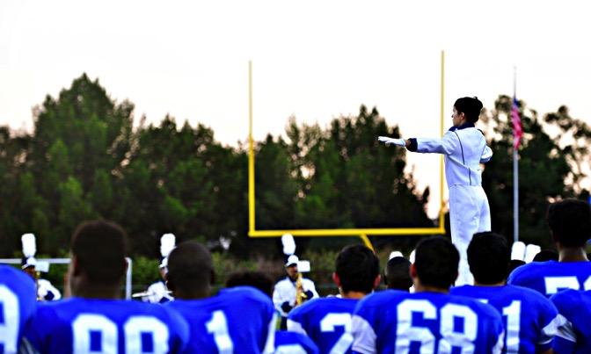

Pali Band Student Leaders

Pali Band Student Leadership was expanded to its current form in fall of 2011. Student Leaders are chosen by the director and staff based on application, interview, and long-term observation of behavior. Chosen students have expanded responsibilities, and are largely responsible for the day-to-day operation of the band, and for their band mates. The positions are constantly evolving and reflect the need of the ensembles, and the potential of the students as perceived by the staff.

The Pali Band Code of Conduct was created by the first class of Student Leaders, 2010-11. The 2013-14 Student Leaders wrote the band’s mission statement and values. The Pali Band Student Leaders will continue to define Pali Band’s vision for all ensembles.

Roles and abilities of all Pali Band Student Leaders

  - Provide leadership; Be a team leader and role model; Note: this is not a position of authority.
  - Foster love of activity/music/organization; Encourage other students
  - Help maintain order through rehearsals by being positive role models
  - With staff, guide the program; Have a vision
  - Be an example of what a band member should be
  - Be available and helpful to new members
  - Help create a fun and controlled atmosphere
  - Stay positive; Keep up other students’ spirits
  - Take initiative to help out
  - Interact with other student leaders
  - Assist in starting rehearsals
- Liaison with other bands; Foster mutual respect
  - Be available for music peer coaching
  - Represent the band within Pali
  - Shepherd
  - Listen to members; Facilitate communication
  - Be prepared to step in for other student leaders
  - Show excellence
  - Always be present
  - Always be on time
  - Take part in band promotion
  - Be a friend in addition to being a leader

List of Possible Student Leader Positions

- President
- Drum Major(s)
- Drum Captain (Battery)
- Front Ensemble Captain
- Color Guard Captain
- Secretary/Treasurer
- Librarian

- Transportation Coordinator
- Equipment Manager(s)
- Section Leaders
Mellophone
  - Low Brass
  - Snare Drum
  - Tenors
  - Bass Drum

  - Flute
  - Clarinet
  - Saxophone
  - High Brass
  - Trumpet

Roles and abilities of specific Pali Band Student Leaders

President
  - Lead Pali Band Student Leaders (schedule meetings, prepare agendas, lead rehearsal debriefs)
  - Represent Pali Band at school-wide events (board, facilities, strategic planning committee, community meetings)
  - Plan and coordinate bonding activities
  - Plan and prepare fundraisers
  - Coordinate Pali Band Banquet
  - Help coordinate Holiday Banquet
  - Communicate with Pali Leadership

Drum Major (s)
  - Conduct and help shape rehearsals
  - Call and conduct football games
  - Start rehearsals
  - Know music (tempos, cues, etc.)
  - Facilitate effective communication between band director and students and student leaders
  - Assist with repertoire choices
  - Assist with marching instruction
  - Coach peers, as needed
  - Communicate with Pali Student Leadership (ASB)

Drum Line Captain
  - Liaison between drum line and band, drum major and staff, front ensemble captain
  - Work with drum majors
  - Assist with repertoire choices
  - Assist with marching instruction
  - Know music (tempos, cues, etc.)
  - Know drill (counts, forms, visuals, etc.)
  - Tap offs
  - Organize drum line sectionals
  - Coach peers, as needed
  - Set up for sectionals
  - Enroll in 7th period drum line
  - Be involved in truck loading

Color Guard Captain
  - Lead and help shape guard rehearsals
  - Know drill
  - Know music cues in drill
  - Know counts for drill
  - Coach peers
  - Facilitate communication between individual members of guard, instructor(s), and director
  - Maintain guard equipment inventory, and make sure equipment is always properly put away; keep guard shed organized and clean
  - Report need for equipment repair to instructor or band director
  - Arrange and oversee carpooling, as needed
  - Commit to spring Color Guard

Secretary
  - Take roll
  - Maintain the student calendar
  - Submit trip requests and bus requests to Pali
  - Prepare, hand out and receive trip slips
  - Take minutes at Band Student Leader meetings
  - Enroll as service worker or dedicate a set time outside of school
  - Facilitate communication with families and students
  - Prepare paperwork and seating charts for festivals
  - Check in the band and submit scores upon arrival at festival

Librarian

  - Promptly prepare music for rehearsals
  - Promptly prepare drill for rehearsals
  - Request additional copies as needed
  - Have knowledge of and maintain the music library, physically and on Charms
  - Enroll as service worker or dedicate a set time outside of school
  - Prepare scores and adjudication sheets for festival

Section Leaders

  - Lead and help shape sectionals and rehearsals
  - Know drill
  - Know music cues in drill
  - Know counts for drill
  - Coach peers
  - Facilitate communication between individual members of section, instructor(s), and director
  - Make sure equipment and uniforms are always properly put away
  - Report need for equipment repair to band director
  - Be able to facilitate an efficient, focused rehearsal
  - Have knowledge of conducting
  - Attend drum major training sessions
  - Have knowledge of instrument fundamentals and instructional techniques
Front Ensemble Captain
- Liaison between front ensemble and marching musicians, drum captain, drum majors and staff
- Work with drum captain
- Organize sectionals
- Know music (tempos, cues, etc.)
- Know counts and set numbers for drill and coach peers, as needed
- Set up for sectionals
- Have a basic knowledge of the PA system
- Lead front ensemble warm ups and rehearsals
- Enroll in 7th period drum line
  - Knowledge of all technique

Equipment Managers

  - Liaison with the Pali plant manager and band directors from whom we borrow equipment, and between drum line, band, drum major, and staff
  - Delegate specific equipment to students and parents
  - Report need for instrument repair to band director
  - Make sure equipment is secure every time it is used and maintain inventory
  - Make sure room and field are secure every time they are used
  - Maintain inventory and repair log on Charms
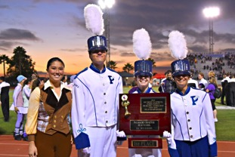
  - Encourage neatness and organization
  - Be familiar with facilities
  - Enroll in 7th period drum line
  - Lead role in truck maintenance
The Staff

A staff member is an adult who is contracted to assist the director by teaching a specialized section. Staff members are needed by high-level performance ensembles. Our staff members are gifted teachers and experienced performers.

At this time, our staff includes:

- Color guard instructors (2)
- Percussion instructors (4)
- Marching instructors (1)
- Brass tech (1)
- Woodwind tech (1)
- Clinicians
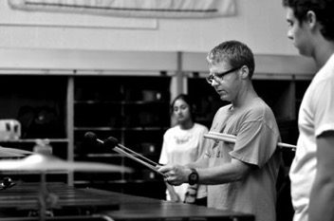
- Music arranger – fall
- Percussion music arranger - fall
- Percussion music arranger - spring
- Drill writer – fall band
- Drill writer – spring percussion
- Drill writer – spring color guard

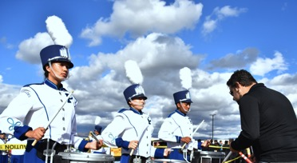

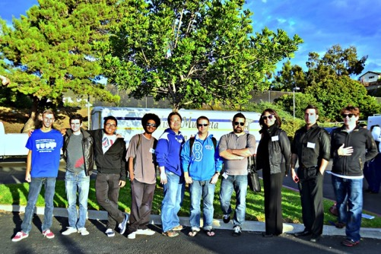
Curriculum and Course Offerings
Wind Ensemble (Period 4) Year-Long

Length: 2 semesters
Credit: 5.0 per semester
Grade Level: 9-12
Postsecondary: Meets UC/CSU requirement
Prerequisites: Audition/Instructor Permission

The PCHS Wind Ensemble meets during fourth period. Wind Ensemble performs in three on-campus concerts per year, and performs masterworks of the concert band repertoire appropriate to the proficiency and pedagogical level of the ensemble. The course includes two to three required school-day curricular trips to performance festivals. Year-long participation is required. Students must provide “concert black” to wear at concerts.

Instructor permission to enroll given by audition. Auditions are held in May.

Symphonic Band (Period 6) Year-Long

Length: 2 semesters
Credit: 5.0 per semester
Grade Level: 9-12
Postsecondary: Meets UC/CSU requirement
Prerequisites: Audition/Instructor Permission

The PCHS Symphonic Band (Concert Band II) meets during sixth period. Symphonic Band performs in three on-campus concerts per year, and performs intermediate to advanced works of the concert band repertoire appropriate to the proficiency and pedagogical level of the ensemble. The course includes two to three required school-day curricular trips to performance festivals. Year-long participation is required. Students must provide “concert black” to wear at concerts.

No audition required!

Marching Band (after school) FallSemester

Length: 1 semester
Grade Level: 9-12

The Palisades Charter High School Marching Band is a one-semester, co-curricular activity. There is a mandatory one-week band camp over the summer. Percussion and color guard members are required to attend additional summer training. The course includes required after-school rehearsals, weekend curricular trips to competitive events, and performances at Pali football games. The Marching Band supports Pali’s football team and special events throughout the year. Enrollment in one of the concert ensembles is required. After the conclusion of fall marching season, color guard members will begin preparation of their spring competitive indoor show. Percussion, Drum Line, and Guard members enroll in sixth period during spring for extra sectional rehearsals. In Spring Semester, those members will be able to reenroll in other band classes if necessary.

In order to facilitate curriculum planning, member applications are due May 30 of the previous academic year.

Drum Line/Color Guard AB Year-Long Course

Length: 2 semesters
Credit: 5.0 per semester
Grade Level: 9-12
Prerequisites: Instructor permission

7th period (2:13-3:08 daily) Drum Line is specifically geared toward students wishing to participate in competitive indoor drum line. In fall, class members will learn percussion rudiments, note reading, pitch identification and proper playing techniques In the winter, students will become part of our competitive indoor drum line. No prior experience is required!

7th period is also our Color Guard class. This class will participate in the marching band in the fall, and work towards their own competitive season in the winter. If you are interested in participating, please contact Allison Wyant, our color guard coach for more information (email: allisumi@gmail.com). No prior experience is required!

Jazz Band (Period 0) Year-Long Course

Length: 2 semesters
Credit: 5.0 per semester
Grade Level: 9-12
Prerequisites: Instructor permission

Jazz Band meets during zero period. No audition is required. Anyone interested in participating should speak to Mr. Dale.

Palisades Charter High School
2019-20 Band Program
Information Sheet

Please print clearly and bring the completed application with you to your audition.

Student’s name: ____________________________________________________________ Gender: M F

Instrument: _________________________________________________ Total years played: ___________

Date of birth (mm/dd/yyyy): _____________________________ Grade in fall of 2018: _________________

Mailing address: _________________________________________________________________________

City: ___________________________________________ State: __________________ Zip: ____________

Home phone: (____)____________________ Student’s cell phone: (____)____________________

Student’s email: __________________________________________________________________________

Primary parent/guardian: ________________________________ Relationship: ______________________

Preferred email: ________________________________________ Cell phone: _______________________

Current private teacher: _________________________________ Years with this teacher: _____________

Previous private teacher(s): ________________________________________________________________

Do you play any other instrument(s)? _______________ If so, list: ________________________________

List current and previous ensemble experience, including Revere and Pali ensembles: ______________

________________________________________________________________________________________

Do you plan on participating in Marching Band as well: Y__ N__

Audition results will be posted at Pali and Revere on the Monday following completed auditions.
Directors reserve the right to change the date of completion.

The Top Ten Things You Should Know as a Band Parent

10. There’s a reason your child comes home excited about band. BAND IS FUN! Your child is completely immersed in a fun activity with their friends. IT’S OKAY FOR THEM TO BE EXCITED! They will calm down after marching season.

9. Your student is probably more capable than you realize.
Even if you have all the time in the world, you will start to feel like a personal servant if you don’t ask your kids to take some responsibility for their own stuff. Water jugs, lunches, props, laundry -- it never ends. Your student can make a sandwich, fill up a water jug, and set out their ‘stuff’. It’s up to you if want them using your washer and dryer, but they’ve got to learn someday.

When you see what they accomplish and how hard they work for someone else, you will be amazed. This is an excellent time to start teaching (if you haven’t already) self-management techniques that will serve them well throughout life. If you are inclined, help them create checklists so that they remember everything they need to bring. It will be a lot of stuff, so be ready.

8. Get out of the car and come join us.
Sounds odd, doesn’t it? Many parents do not realize that they can enter the band room without ill effect. Be respectful of practices going on, but come on in and see what is happening. Frequently, there are parents working on projects or hanging around. The last 15-20 minutes of practice will be a run through of what the kids have learned so far. Watching the evolution of the band and the kids is really inspiring. It will blow your mind what your kid can do! And believe it or not, you will not see the same *exact* show week after week. Bring the family and enjoy the show, but remember to stay quiet so you don’t distract the kids.

On competition days, come inside after the band returns. This is a good time to congratulate or encourage your student. Drop by before they leave to let them know you support them. You may feel a bit more like a spectator than a parent, but the kids know you are there and they appreciate it.

7. Learn to manage your time and teach your student how to manage theirs.
You WILL be busy -- especially from August until the first of December. You will receive calendars in emails, but you MUST find a way to keep track of everything that works for you. More importantly, your student will have to balance band and school work. It is not easy, but it can be done. Most band members carry a full load of classes; many are honor students with AP classes. You will have to find pockets of time for homework and other responsibilities. Some students do homework on the bus when necessary. High school is already a big adjustment. Between band and school there won’t be much time for anything else. But it doesn’t last forever and they will miss it when it is over.

6. Bring cash, warm clothes and something to sit on.
Most school functions require that you bring cash. Competition venues charge admission, anywhere from $5 to $10 per person. Children under 5 are usually admitted free. You MUST bring cash. Concessions are cash only, as are some souvenir vendors.
Aluminum benches are hard and COLD, especially in October. Many of the events are outside. Plan accordingly. Something to sit on will make the experience more enjoyable and keep the cold from creeping in. Many parents bring a blanket or fleece to ward off the chill. Hats, gloves, scarves will help keep you comfortable. Obviously, if it is sunny out, remember sunscreen, hats and sunglasses. Just like the scouting motto: BE PREPARED.

5. Band Directors are people, too.
They work long hours and their main focus is the kids. If you have a specific concern about your child and the band program, set up a time to discuss it. If you need general information, directors are probably not your best resource. Try a fellow parent first.

On another note: Marching band requires dedication and discipline from your student. The job of the directors is to help your student excel in band. Directors speak loudly, pointedly and sometimes without pleasantries. When mistakes are made, especially due to inattention or lack of effort, there are consequences. Try to relax and allow the process to work. Encourage your student to do their best, listen, and work hard. Everyone wants your child to be successful. You will learn this as you move through the season.

4. You are not alone! Every parent -- okay, MOST parents, feel overwhelmed at first. The whole first year is a scramble to keep up. Here are some good phrases to put into use: “Excuse me, I’m new and I was wondering ...”, “Hi, I’m a freshman parent, my name is …” “I’m Ben’s mom and I heard …” You will be surprised how quickly you will be pulled into the fold. Timing is everything, of course. If you ask someone who is obviously busy, you may not get the welcome you hoped for. Rarely are other parents too busy to help you. We want you to join us and we love to share our experience with you.

Your student will be making all kinds of new friends, why shouldn’t you? You can find people to carpool with, volunteer with, celebrate with, and commiserate with. Band parents are valuable resources. They can help you find solutions to your dilemmas, and there will be dilemmas. You will also get to know the parents of the kids your student is hanging around. What a bonus!

3. We can’t do it without you—volunteer and come to the booster meetings.
You will be asked to commit time, energy, donations and the band fees to the band program. Unlike many sports programs, the PCHS Band must have parent volunteers for the programs to run smoothly –- and it is the best way to get to know others. Plan to attend as many Booster meetings as you can. Ms. Hernandez usually addresses the parents with updates on the show and will answer parent questions. It is time well spent.

About volunteering … no experience necessary. No, REALLY! There are tasks that require specific skills, but most opportunities do not. If you can pull a soda from a cooler, take tickets at a gate, use scissors, sew or build props - you have all the skills you need. Better yet, there is so much to do, you are bound to find something you actually enjoy doing. At first it looks like everyone else knows what is going on but you. Take the initiative “I am new, and I’m here to help.” We will put you to work straight away at something that is not far outside your comfort zone. It may be just a little outside, and the feeling will pass quickly. It won’t hurt a bit. You will be helping keep YOUR band fees down and have fun doing it. Trust us, we’ve been there.

2. Join the CHARMS website! Read your emails!
This could be said a thousand times and still not be said enough. As the season progresses, you will get multiple messages each day. READ THEM. CHECK YOUR EMAIL DAILY. You may not always completely understand the emails, but READ THEM.

1. Yes, it’s worth it!
All of the rides, time, and effort (and it is extraordinarily a lot) that as a parent, you put into getting your child to practices are worth every second. You may not be able to appreciate that in the beginning. Your student may get discouraged at first. There is a lot of repetition, hot sweaty days, failures, and disappointments. Then the show starts to come together and everything changes. There is a new energy, a new excitement. This is the point where they will either LOVE band, or plan a different activity next year. Most of the kids LOVE band by the end of the season, so make them tough it out for the whole season. It will be worth it. You may be uncomfortable at points. You will feel unsure. If you can push past the confusion and the chaos, you will probably get hooked like the rest of us. There is no way to describe how amazing this experience can be, but if you get involved you will find out for yourself.

NOTE: If you’ve only read this far you are already ahead of where many of us were when we joined. Hold fast to your handbooks (put them someplace you can find them, like a binder or folder), sign up for CHARMS and attend the Booster Meetings.
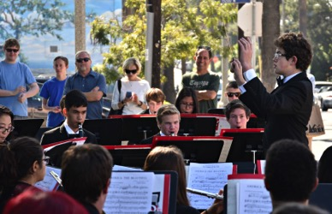

Fair-Share Donations & Tax-Deductible Direct Donations
In order to cover the cost of band camp, instruments, extra staffing, music, equipment, transportation, and other service needs, it is necessary to assess a “Fair-Share Donation” for participating in fall marching band, spring drum line and spring color guard. Each student is assessed $1000. **

There will be weeks when your student will spend up to 20 extracurricular hours with the band programs.
Please support the efforts of our students, staff and directors with your financial contributions.
We CANNOT continue these activities without your monetary support.
WE NEED 100% PARTICIPATION IN FAIR-SHARE DONATIONS TO HELP OUR PROGRAMS THRIVE!
Please be prompt with your Fair-Share Donations. Individual statements are emailed via CHARMS. Please make sure your most current (and frequently checked) email address listed in CHARMS.
1. Single Payment: Payment in full no later than May 1st, 2019.

2. Monthly Payment: Payment must be received no later than the 15st of each month as shown below.

**Families with demonstrated financial need may apply for financial aid in meeting their unpaid balance. Financial aid is not offered for uniforms, supplies, shirts or shoes. Please communicate with the director by submitting page 44, AND by email or face-to-face.
***Students/families owing a balance on their band account from the previous year must pay the balance in full by June 1st in order to enroll for the upcoming year.

All checks should be made out to
Palisades Charter High School with Marching Band in the memo.

Send to: Alex Dale, Band Director
Palisades Charter High School
15777 Bowdoin Street
Pacific Palisades, CA 90272

DUE DATE | Due Date
Marching Band Fair-Share Donation #1 - $168 | May 1, 2019
Marching Band Fair-Share Donation #2 - $168 | May 15, 2019
Marching Band Fair-Share Donation #3 - $168 | June 15, 2019
Marching Band Fair-Share Donation #4 - $168 | July 15, 2019
Fall Color Guard Uniform - $180 | August 15, 2019
Marching Band Fair-Share Donation #5 - $168 | August 15, 2019
Marching Band Fair-Share Donation #6 - $168 | September 15, 2019
2018 Spring Color Guard/Drum Line Fair-Share Donation #1 - $130 | October 15, 2019
2018 Spring Color Guard/Drum Line Fair-Share Donation #2 - $130 | November 15, 2019
2018 Spring Color Guard/Drum Line Fair-Share Donation #3 - $130 | December 15, 2019
Spring Color Guard/Drum Line Uniform - $180 | December 15, 2019
2018 Spring Color Guard/Drum Line Fair-Share Donation #4 - $130 | January 15, 2020
2018 Spring Color Guard/Drum Line Fair-Share Donation #5 - $130 | February 15, 2020
2018 Spring Color Guard/Drum Line Fair-Share Donation #6 - $130 | March 15, 2020

Why do we have Marching Band Fair-Share Donations?
Years ago school systems were better able to support extracurricular activities such as marching bands. As we all know, budget cuts and decreased state revenues have all but stopped school funding for extracurricular activities. In order to have a Marching Band, we ask our Pali High Students to all participate in Fair-Share Donation expenses. No exceptions please!
Where does the money go?
Fair-Share Donations pay all of the basic costs to support the Marching Band. These include transportation, instructors, equipment, repair and purchase of instruments, purchase and cleaning of uniforms, and music among other things.
How much is the Pali High Marching Band Fair-Share Donation?
The Fair-Share Donation for the 2019-20 school year is $1000 per student. Partial scholarships available upon request. Younger siblings enrolled in the programs will receive an automatic waiver of 50%. Unpaid accounts will be passed on to Pali administration for collection.
Are these fees tax deductible?
Yes. You will receive a letter from Pali High Administration for your tax records two times a year (July and January).
May I make a larger donation to the Pali High Marching Band?
Yes again! And we hope you will!
Charmsoffice.com is the main mode of communication within Pali Band. Calendar, student records and emails are all maintained and sent through Charms. Need more information? Check Charms!

____________________________________________________________

How to access parent/student information in

- Log on to www.charmsoffice.com, and click the “ENTER/LOG IN” link at upper right.

- Locate the “PARENT/STUDENT/MEMBERS LOGIN” section of the web page.

- Login to your child’s program account using the following School Code:

PALIHIGHMUSIC

- This will bring up the main parent page. This will allow you to look at the “public” calendar for your organization, event list, handouts and other files.

- Clicking on an event on the calendar brings up the details for that event, such as times, attendance requirements, volunteer opportunities, and other event details. Note that if a calendar event is specifically assigned to your child, it may NOT show up on this calendar – check the “Student” calendar after entering the student’s ID number (see below).

- When you enter your child’s ID NUMBER (<FIRST INITIAL><LAST NAME>) as a Student Area Password, another more detailed screen appears with even more options to view your student’s uniform assignments, music assignments, financial records, forms and inventory. Once you have first entered this ID number, you may create your own, unique password by clicking on the “lock” (Change Password) icon.

- Update Personal Information – you may help make changes to your child’s student information page (such as updating phone numbers and email addresses if they change) to help the teacher communicate with you more effectively. Click the Personal Info button.

- You will also see links to enter Practice Logs, view Grades, and use the Recording Studio if the teacher has enabled these options.

- Most importantly, the parent page assists both you and the teacher to communicate with each other. Stay up to date on what’s going on with your student!

Equipment/Uniform
Allof the school equipment/uniforms will be of high quality and repair, and must be cared for appropriately. All school instruments/uniforms will be inspected before being checked out to you at the beginning of your membership, or if you change instruments/uniforms. It will then be inspected again at the end of the term of use. You will be held financially responsible for any and all damage, including dents, major scratches, missing parts, etc. Please, always care for your equipment/uniforms. Well-maintained equipment is a "competitive edge".

Rehearsal Dress

Because of the visual nature of marching band, students will wear uniform rehearsal clothing to all rehearsals, including 6th period classes. Failure to wear dress for rehearsal will affect the student’s weekly participation grade.

Rehearsal dress consists of:
- Royal blue or white rehearsal shirt (multiple rehearsal shirts are suggested) - $10
- Royal blue band hoodie - $40
- Black shorts or black sweats/stretch pants (Pali PE shorts are acceptable)
- Athletic shoes

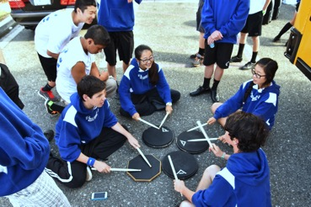

Performance Dress

Under their uniform, marching band members will wear the following:
- White show shirt with multi-color Pali crest - $25
- Black compression shorts
- Tall, black socks
- Black Dinkles Vanguard Marching Band Shoes (leather)

Band members must buy their own marching shoes (Dinkles). Go to bandshoppe.com to purchase.

http://www.bandshoppe.com/catalog/productDetail.do?p=Dinkles_Vanguard_Marching_Band_Shoes
Marching Band Uniform Care
or
How to Hang Up Your Uniform Properly
1. One Marching Band uniform costs approximately $400. You and your parents purchase these uniforms through fair-share donations or volunteer work on fundraisers. That money doesn't have to go to uniform replacements as often if we take good care of what we have.
2. Section leaders will assist you in caring for your uniform.
3. Uniforms should look good on the student and on the hanger. When a uniform is hung up properly, it will look good all season long. Often the uniforms finish a performance damp with rain or sweat. If the uniform is not hung up correctly, it will "dry" in that condition and look bad the next time it is worn.
4. The basic steps to hang up a uniform are:
a. Pants first. Turn the pants upside down, aligning the seams and the pleats. All four seams should match (seams are the line that is sewn down the inside and outside of the pants leg). The four pleats should hang completely straight and flat (the pleat is the crease in the front and back of the leg). You should be able to hold the pants from the bottom of the legs and see the uniform hanging flat and straight. When you get this right, you'll know it. If the seams and pleats do not match, the uniform will never hang straight.
b. Place the pants over the hanger and pull the legs down so that the bottom of the pants hangs about even with the shoulder straps. If one side hangs much longer than the other, the pants will not hang correctly.
c. Jackets next. The jacket goes on the hanger so that your name and the numbers can be seen from the front of the jacket. That way, all the uniforms hang facing the same direction. This makes finding your uniform the next time you need it much easier and quicker.
d. Zip the jacket ALL the way up and hook the clasp. Zipping the jacket up allows the jacket shoulders to hang and dry on the large hanger correctly (see #3 above).
e. Place your uniform in the uniform rack section labeled with your number. If you put it in the correct spot, it will be easy to find the next time you need it!
5. Every marcher will be issued a new pair of gloves on the first day we wear uniforms. You can wash your gloves in the washing machine. Don’t throw them away! Gloves MUST be white for each performance. If your gloves are not white, you will be given a new pair of gloves and your Charms account will be charged.
6. Black socks. Every time. Any time you forget your black socks, you become a rookie freshman again, no matter how tall you are, how old you are, or what grade you are in.
7. Black shoes. Otherwise known as Dinkles. Take them home! We do not have space for you to store ANYTHING but music and instruments in the Pali Band Room!
8. Shakos (band hats) and shako boxes. Storing your gloves in your hat box is a pretty good idea. Storing 5 or 6 pairs of dirty gloves and socks, candy, and food in your hat box is NOT.
9. Returning uniforms to the uniform closets after a performance. Yes, we know you've got things to do and places to go and people to see. Believe it or not, so do the uniform moms and student leaders. Getting 80 uniforms stored properly after a performance is a big job but an easy one if each student does their part. If just thirty uniforms are put away incorrectly, that can become an extra hour of work for the student leaders.

How can YOU avoid the doing it wrong? There are a couple options:
a. Learn to hang your uniform up correctly. It isn't hard. Si, se puede!
b. Ask your section leader to assist you. They like to help.
c. Ask a friend to help you if they know how to do it correctly.
d. Pay a friend to help you. Or barter.
The missing option is asking a parent to do it for you. You will be asked nicely to go to try again (see options a through d).
10. Missing buttons, hat straps, stains, and other problems. If you lose a button or a hat strap/chain or your zipper breaks or you tear (please, no!) your uniform, write on the white board. We are always equipped to make emergency repairs because we are amazing, and will soon be invincible.
11. Hair, jewelry, nail polish and make-up. Hair must be completely up inside your shako. If you need hair clips and bands ask, but preferably, take responsibility for this ahead of time. No make-up, nail polish or face glitter when in uniform. None. No earrings. None, not even tiny, little ones. You can wear them after the performance. Hair bands and bobby pins should match your hair. No red, or even blue.
12. Do NOT wear bulky shorts, jeans, or pants under your uniform, even if it is cold! Thermal underwear might be necessary later in the season, and should be worn close to the skin. Jeans and shorts do not work. Here are links to the Under Armour equivalent of what you should wear under your uniform. Cheaper options are available. Dig!
Men’s
http://www.underarmour.com/shop/us/en/pcid1000025?cagpspn=pla&CAWELAID=1257033995&cid=PS%7CGoogle%7CPLA&gclid=CP_s54TPiLACFWIGRQodGD-VNw
Women’s
http://www.underarmour.com/shop/us/en/womens-ultra-7-team-compression-short/pid1001226-001
13. Shako plumes (band hat feathers) are very fragile. Each plume is stored in its own individual cardboard tube and fluffed by loving plume parents. You will notice that the plumes are inserted into your hat before each performance by one of these obsessive plume parents. There is a reason for this! The plumes must be handled carefully and inserted by holding on to the base metal piece only. Unfortunately, the plume parents are not numerous enough to catch every marcher as the band exits the field. Leave your plume in your shako until there is an available parent. By doing so, you are adding years on to the lives of the plumes - and the plume parents! And it’s fun to watch you all bow to the parents. Especially if you are tall and the parent is short.
14. That's about it. Have fun, and a great marching season!
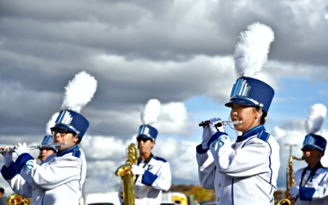

DeMoulin (uniform maker) Guidelines

Wearer’s Responsibilities
- Read and understand the complete user care responsibilities contained herein and on the care label inside each uniform garment piece.
- Do not wash the uniform garment. Professional dry clean only.
- Do not hand clean in any manner. Professional dry clean only.
- Do not tumble dry or heat in any manner (such as hand ironing, blow during, or over a hot stove) a wet uniform garment piece. Hang properly and allow to air dry at ambient conditions. Follow-up promptly after air drying with requisite dry cleaning and/or pressing.
- Do not contact uniform garment (for the purpose of modifying condition surrounding use of the garment) with:
  - Anti-stains,
  - Water/oil proofers,
  - Spot cleaning chemicals,
  - Other topical chemicals such as: bleaches, spray deodorants, perfumes, brighteners, facial makeup, etc.
- Examine the uniform garment after each use for soiling, stains, etc.
- Abnormally stained uniform garments should be cleaned as soon as possible after the staining occurs by the approved professional dry cleaner. Do not attempt to hand clean.
- Do not store uniform garment wet. Follow-up as in 4 above.
- Do not store uniform garment for long periods of time such as at the end of the current band use season until the next band use season. Time tends to set stains.
- Examine uniform garments at the dry cleaners after cleaning to determine whether or not the identified stains have been removed or if staining has occurred on dry cleaning and/or pressing. Follow up undesirable vaiances immediately.
- Examine uniform garment before dry cleaning and identify location and type of stain (if possible) to the dry cleaner on delivery of the garment for cleaning.
- Do not hand press for touch up. Professional press only.
- Any unsatisfactory condition found after all of the above have been followed up rigorously should be referred to the uniform garment manufacturer first.

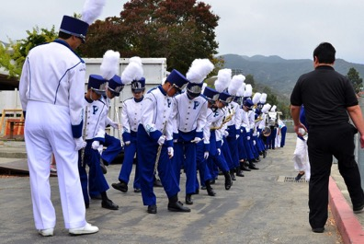

Front Ensemble
The PCHS Marching Band’s front ensemble (the percussion that stand in front of the marching band) wears traditional concert black. Our shows are designed with this “concert feel” in mind. The front ensemble must adhere to the concert attire guidelines found in the handbook. Please make sure that your concert attire is prepared for the first performance of the show.
Concert Attire Guidelines
The dress guidelines outlined here are strongly enforced to ensure that everyone in the ensemble is dressed professionally for performances. If in doubt as to what to wear, you should stay as conservative as possible; use common sense here. Any students who arrive for a concert improperly dressed will be sent home to change or, if this is not possible, may be pulled from the concert.
Men
- Black tuxedo or suit.
- Pressed white dress shirt.
- Black socks and black dress shoes. Dinkles are acceptable.
- Black cummerbund or black tuxedo vest.
- Suspenders are permitted, but must be either black or white.
- Black bow tie.
Women
- Plain black, floor to mid-calf length gown with long or 3/4 sleeves.
OR
- Long or mid-calf black skirt, or black dress slacks, with a black top having long or 3/4 sleeves. If you wear slacks, they must be wide, loose, and flowing - nothing tight, and no jeans.
- Black hose and black dress shoes. No open-toed shoes or sandals.
- No excessive jewelry. No sequins or sparkles. Hair accessories must be black, silver, or gold.
- No plunging necklines, rising slits (dress and skirt slits must not exceed six inches in length), low-cut backs, or displays of midriff. Wear a slip if your outfit requires it.
- A basic rule for the women is that we should not be able to see your feet, legs, knees, or elbows.
http://www.peabody.jhu.edu/3970 (slightly adapted for the PCHS Concert Band)
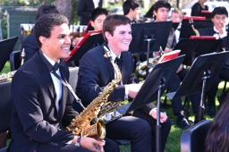

Required Student Supplies

All students must have the following items for every marching band and outdoor drum line rehearsal:

- Athletic shoes
- Sunscreen & sun protection
- Water in a refillable bottle
- Draw-string bag for rehearsal clothes, music folder, warm layers and shoes

In addition, students will require the items specific to their instrument:

6th Period Marching Band/Concert Band Wind Players
- Instrument (your own or assigned, as decided with the director) and all necessary accessories (valve oil, mouthpiece, reeds, cork grease, etc.)
- Your own ¾ inch 3-ring binder and page protectors (must be ¾ inch or less – NO LARGER)
- A Marching Band Lyre specific to your instrument (peppermusic.com)
- Music Flip-Folder (includes 10 pages), plus Marching Band Flip Folder Pages (extra pages) (peppermusic.com)
- Foundations for Superior Performance: Warm-Ups & Technique for Band for your instrument (peppermusic.com)
- Korg TM-40 Digital Tuner/Metronome (peppermusic.com)

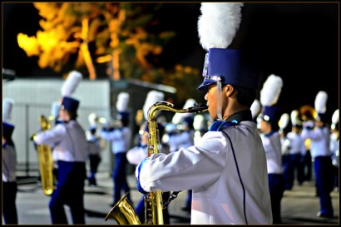

You don’t need to have the items below until the first performance
- Clean white gloves – Three pairs will be supplied per year. To purchase additional gloves: http://bandshoppe.com/catalog/productDetail.do?p=Nylon_Polyester_Marching_Band_Gloves
- Knee-high black socks
- Black compression shorts for under your uniform

Recommended Mouthpieces

It is not required that a new member buy a new mouthpiece upon joining the band, but most horns are sold with low quality mouthpieces, and you will certainly notice the difference in your sound and response of your instrument. Following is a chart for recommended mouthpieces:
Instrument Brand/Size
Clarinet (Bb) Van Doren B45
Alto Sax Selmer S80 C*
Tenor Sax Selmer S80 C*
Mellophone Marcinkiewicz M5-a-20
Trumpet Bach 7C
French Horn Schilke
Trombone/Baritone Bach 6.5 AL (small shank)
Sousaphone/Tuba Conn Helleberg 120 Standard

Suggested Saxophone Supplies

Mouthpieces
Selmer s80, C* (C Star) Facing
Selmer s90, 180 Facing
Meyer 5, Medium Chamber (Don’t use the ligature that comes with it)
Yamaha 4C - research

Ligatures
Rovner dark ligature
Standard Selmer Ligature

Reeds
Vandoren (Blue Box)
Alexander Superial

Reed Case to keep reeds flat and unbroken

6th Period Marching Band Drummers
- Your own ¾ inch 3-ring binder and page protectors (must be ¾ inch or less – NO LARGER)
- Digital Metronome that can play subdivisions (Korg MA30, Dr. Beat)

You don’t need to have the items below until the first performance
- Knee-high black socks
- Black compression shorts for under your uniform

6th Period Concert Band Drummers
- Stick Bag
- Concert Snare Drum Sticks (Vic Firth SD1, SD2)
- Yarn Marimba Mallets (Vic Firth M183)
- Timpani Mallets (Vic Firth T1 General)
- Bell/Xylophone Mallets (Vic Firth M134)
- Digital Metronome that can play subdivisions (Korg MA30, Dr. Beat)
6th Period Color Guard Members
- Rifle - https://www.designsbyking.com/rifles_and_accessories.php
36-inch rifle w silver bolt, a white leather strap, and strapping tape
- Flag bag - https://www.designsbyking.com/equipment_bags.php
$35 flag bag holds 6 foot poles and 40 inch weapons; black; you may choose to customize with your name for an additional $8
- Tan fingerless gloves - https://www.designsbyking.com/other_products.php

7th Period Fall Drum Line
- 1 Pair of Vic Firth Ralph Hardimon Corpsmaster Drum Sticks (wood tip)
- Rubber practice pad 12” – Vic Firth Heavyhitter Slimpad 12” Practice Pad
- Digital Metronome that can play subdivisions (Korg MA1, Dr. Beat)
- Your own ¾ inch 3-ring binder and page protectors (must be ¾ inch or less – NO LARGER)

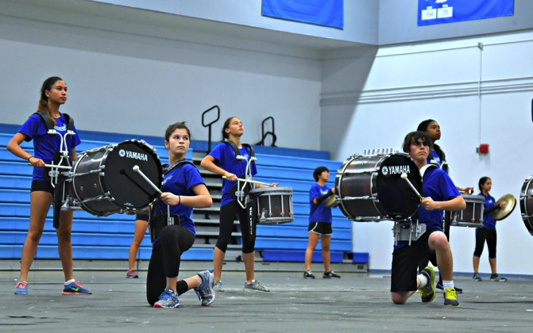

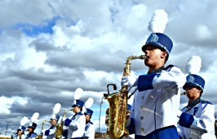
Forms Schedule

Parent Signature Form May 30
Emergency Card June 1
Marching Band Permission Slip September 1
Spring Concert Band/Color Guard/Drum Line February 1
Permission Slip

2018-19 Palisades Charter High School Marching Band
Form Check List

Fair-Share Donation #1 May 15, 2019

Parent Signature Form May 30 final due date
Shirt and Hoodie Form and Payment May 31
Emergency Card May 31
Parent Volunteer Form May 31
Palisades School Charter Complex 4th of July Membership Form June 15
Marching Band Permission Slip October 1
Concert Band/Color Guard/Drum Line Permission Slip February 1, 2020
After submitting your Parent Signature Form,
please login to Charmsoffice.com and fill in further information.
School code: palihighmusic login: <first initial><last name>

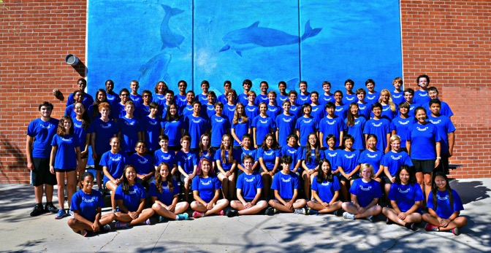

Letter of Intent
Please sign and return by May 30th to be guaranteed a spot in the 2019 show

____________________________________ _____________________________________
Member’s Name (Print) Parent’s Name (Print)

Members: I have read and understand the Palisades Charter High School Marching Band, Drum Line and Color Guard Handbook, including the Code of Conduct, and agree to follow its rules and policies.

Parents: I have also read and understand the responsibilities of parents of members and agree to support my son/daughter in their chosen activity. I will also participate in a team and attend at least four activities during the school year. At the end of my son’s/daughter’s tenure with the Pali Band, all monies left in their account will be transferred to the band’s operational account.

Photo Release: I give permission for my child to be photographed and/or video recorded at Pali Band functions.

I will participate in/attend at least two of the following fundraising/volunteer activities:

2019 Marching Band Tournaments (see volunteer form for organization needs)
2020 Spring Drum Line Competitions (see volunteer form for organization needs)
2020 Spring Color Guard Competitions (see volunteer form for organization needs)
6th Annual Holiday Banquet & Boutique Fundraiser
Spring Fundraiser

_________________________________________________ ______________________
Member’s Signature Date

_________________________________________________ ______________________
Parent’s Signature Date

___________________________________ _____________________________________
Parent’s Email Address Parent’s Cell Number

___________________________________ _____________________________________
Member’s Email Address Member’s Cell Number

___________________________________________________________________________Home Address

__________ ________________ ___________________ Y N
Grade T-Shirt Size Instrument Personal Instrument
2019-20 Palisades Charter High School Marching Band, Drum Line and Color Guard
Parent Volunteer Form

First name Last Name

Student(s) Name

Parent Volunteer email Parent Volunteer phone number #

I/We are willing to help with (check all that apply):
- Chaperones – for home games, away games, competition, special events (Game chaperones help with water, plumes, equipment during half time, For away events, chaperones are expected to travel on the bus to and from event, take care of band needs: water, moving equipment, emergency uniform repairs)
- Chaperones – for spring tour. Past tours have been to Seattle, San Francisco, New Orleans and Yosemite. Tour chaperones are asked to pay for their trip.
- Data entry/check entry – receive Fair-Share Donation checks and enter them into Charms
- End-of-Year Banquet Committee – find a site for, and organize, the students’ end-of-the-year banquet
- Equipment (Marching Band; Spring Drum Line)
- Food/Water Committee – organize food, water and ice donations for home games and out of town competition
- Football games – deliver water to stands, place/remove seat cushion in stadium for band members, and pick up trash.
- Fourth of July PAPA Liaison – Attend Palisades Americanism Parade Association meetings as band rep
- Fundraising - Raise money for the band/organize fundraising
- Hair/make-up Crew (marching band)– Assist band members with hair and make-up application. Donate hairspray, gel, hair pins and hair ties(rubber bands) when needed.
- Hair and Costuming (fall/spring color guard) – assist staff as they design hair and makeup, and prepare students on show days
- Hair and Costuming (spring drum line) – assist staff as they design hair and makeup, and prepare students on show days
- Holiday Banquet Committee- planning, decorating, setup/cleanup, food for Winter Banquet
- LCFF/LCAP Advocates – Attend monthly Pali Long-Term Strategic Planning meetings to advocate for the interests of music education at Pali
- Merchandise Sales- help selling t-shirts and other spirit items at special events
- Overnight Trip Coordinator
- Pali Booster – Join PCHS Boosters, Pali Band’s top donor; attend monthly Pali Booster meetings
- Prop Making/Shelving Installation (woodworking, carpentry, metalworking, welding, fabrication experience)
- Prop Coordination – find prop designers, within the program or professionals; facilitate communication between staff and prop makers
- Public Relations and Advertising – prepare short write-ups on program successes for local media; advertise band events; prepare concert programs
- Truck driving: for out of town competitions. Pick up/ return truck at rental agency in SM
- Uniform Fitting – Assist with or organize uniform fittings and alterations, sewing, record keeping before and during season
- Uniforms/Shakos crew- Assist band with uniforms/ plumes before and after games/competitions. Care of plumes/order or repair damaged plumes/shakos.
- Videographer – Make videos of marching band, concert bands, drum line and color guard for staff and student use
- Village Green Coordinator – determine what we need and how to get it there for our thrice-yearly Village Green fundraisers
- Volunteer Coordinator – make sure enough parents are signed up for special events/football games/out of town competition.
- Any other interest, special talents or skill?__________________________________________

Palisades Charter High School Marching Band, Drum Line & Color Guard
Gear Order Form

Student: ___________________________________ Email: ___________________________
Parent: ____________________________________ Phone: __________________________

Item | Indicate quantity per size | Price | Cost
Royal Blue Rehearsal Shirt (Musicians) | XS___ S___ M___ L___ XL___ | $10
White Performance  Shirt (multi-color logo) | XS___ S___ M___ L___ XL___ | $25
Royal Blue Hoodie with last name embroidery | XS___ S___ M___ L___ XL___ | $40
White Rehearsal Shirt (Colorguard) | XS___ S___ M___ L___ XL___ | $10
Make checks payable to:  Palisades Charter High School with Marching Band in the memo |  | Total:

Palisades Charter High School
Instrumental Ensembles and Color Guard
2019-20
Fair-Share Donation Waiver Application

Finances should not stop anyone from taking part in Pali music.

Families requesting aid must complete this form prior to Fair-Share Donation due dates. If no alternative arrangements are made, the contribution will be due in full by the dates indicated on the schedule. Please submit your Fair-Share Donation Application to the director. Your request will remain confidential.
Fee waivers up to 50% will be considered for ensemble. Tour fees, uniform fees and equipment fees will not be waived.
Student Name ___________________________________________________ Grade ________________________
Adult 1 Signature ________________________________ Adult 2 Signature _________________________________

Waiver Request

Ensembles: □ Marching Band ($1000)
Instrument Played ______________________ Waiver Amount Requested _____________________________

□ 7th Period Spring Drum Line ($850) Waiver Amount Requested _____________________________

□ 7th Period Spring Color Guard ($750) Waiver Amount Requested _____________________________

□ Wind Ensemble or Orchestra ($250) Waiver Amount Requested _____________________________

Installment Plan Request (remember to include all uniform and gear fees, in addition to contributions)

□ Weekly Amount $___________________ Start date _____________________ End date _____________________

□ Semi Weekly Amount $___________________ Start date _____________________ End date _____________________

□ Monthly Amount $___________________ Start date _____________________ End date _____________________

Families that request waivers are asked to participate in fundraising and volunteer activities on behalf of the program.

Send to: Alex Dale, Band Director
Palisades Charter High School
15777 Bowdoin Street
Pacific Palisades, CA 90272
or
palihighbands@gmail.com

……………………………………………………………………………………………………………………………………………………….....

For Director Use

Date received ____________________________________

Installment Plan Approved __________________________

Amount Waived $__________________________________

Copy to Applicant __________________________________

A CALIFORNIA DISTINGUISHED SCHOOL

Dear Supporter of Music,

In order to further our students’ musical experiences, the Palisades Charter High School Marching Band is seeking donations, ﬁnancial support, and volunteers from individuals, businesses, and community organizations. With your donation we hope to provide opportunities for students to have an enriching musical education beyond what local schools are able to supply.

May we rely on your support for our award-winning music program for the 2016-17 school year?

We are seeking monetary and in-kind donations to help maximize the ﬁnances received through family donations and fundraising. Your donation helps us provide students with performance opportunities and training. In return, we will advertise your business or organization as one that supports our ongoing efforts to enrich the community and school musical offerings. Sponsors are acknowledged at our winter and spring concerts, and are supported by our 120 grateful families.

Ensemble members and their families work hard throughout the year to raise funds. In addition to their musical and fundraising endeavors, students in the music program are required to keep their grades up and to participate in practices, performances, and competitions. Our students sacrifice because their lives are enriched by music. Palisades Charter High School wants every student to have the opportunity to go higher and further with his or her musical skills and abilities. We need your help and support! Your tax-deductible donation will help our students achieve their musical goals.

Thank you in advance for supporting music at Palisades Charter High School.

Sincerely,
Alex Dale
Director of Band Programs
palihighbands@gmail.com
310.857.8057

